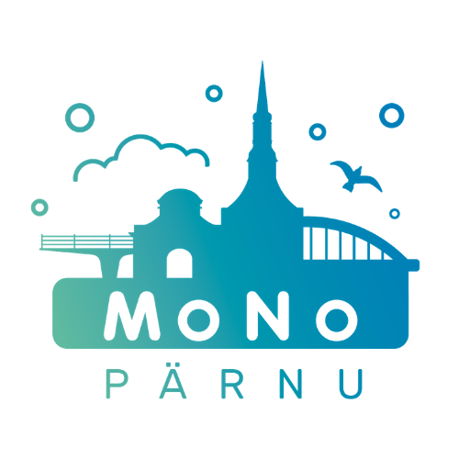

MTÜ Pärnumaa Noorsootöö Keskus

Noorte Väljak 2, Pärnu

Regkood 80574896

IBAN EE491010220293470220

mono@vabaajakeskus.ee

To the crew of the Pärnu MoNo Date:
Motivation Letter
To participate in the Pärnu MoNo street work

- For what reason do you want to participate in Pärnu MoNo street work (personal interest and professional interest)?
- How and where do you intend to share the experience you gained?
- What added value does your participation in street work bring to the Pärnu MoNo team, young people and yourself?
- What are your expectations for the Pärnu MoNo team in street work?
- What topics can you talk to young people about? In what area do you feel competent? Your so-called special skills :)
- Fears, hesitations, doubts related to street work.

Name
Contact (phone number, e-mail)
Job / school

